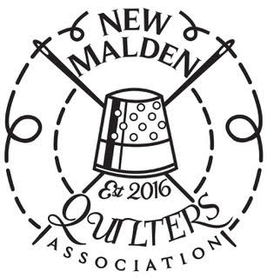

The New Malden Quilters Association is pleased to announce the launch of a Young Quilters group for everyone between the ages of 5 and 18 inclusive. This group is being run in association with The Quilters’ Guild Young Quilters.

The first monthly workshop will be on Saturday, 29th September from 1.30-4pm at:

The Community Hall
The Hamptons
Green Lane
Worcester Park
KT4
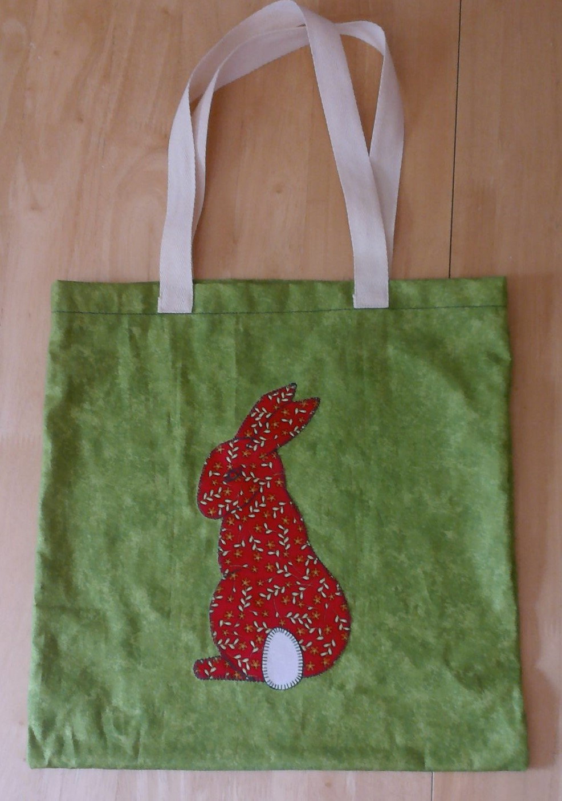

The cost for the 2.5 hour workshop will be £7.50 and will
include membership of The Quilters’ Guild Young Quilters as
well as all materials and equipment required to make a tote
bag with an applique patch.

All children age 7 or under must be accompanied by a
parent or carer for the duration of the workshop.

For further information please contact Sue Thornborough by email at farnboroughskid@gmail.com


