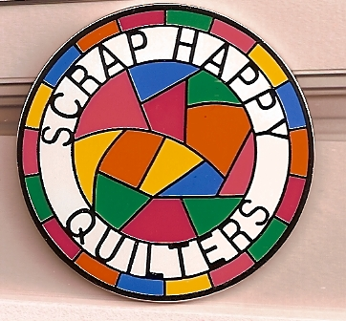
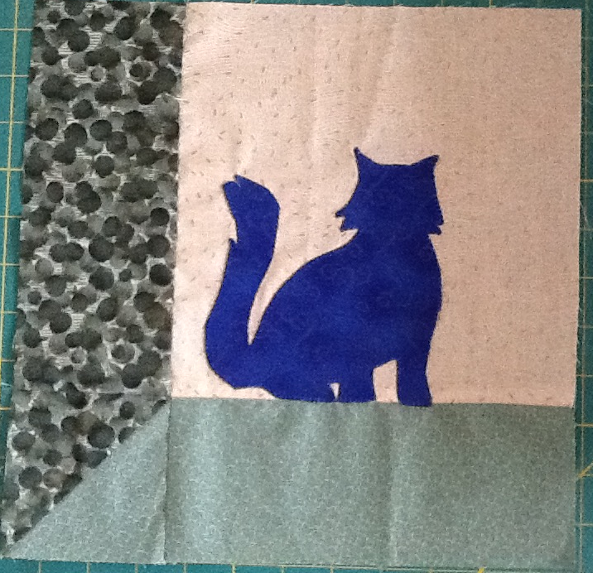
Scrap Happy
Young Quilters.
June 2015

Cat in the attic.
This is a pattern called Attic Windows.
I have added a cat to sit in the window – but if you want to put in a different animal or other shape, bring along an outline drawing which fits a square no larger than 6” and you can use that. You could leave out the cat altogether and use a patterned fabric for the window scene.
Lots of possibilities!

It uses 4 fabrics – two of which should be a light and a dark – not necessarily the same colour though, ie., not a light green and a dark green as I have used in this sample.

The cat needs to stand out, so choose a contrasting fabric.

We will use Bondaweb to attach the cat to the block.

Cutting instructions are on the template sheet.

Please bring with you the two triangle templates, cut from card. These are the most ‘fiddley’ of the pattern pieces.

If you want to make templates to cut the strips out, feel free! The sizes are given on the template sheet.

A
B
C
D
E
Sewing order:
A + E
B + D
(B + D) + C
(B + D +C)
Bondaweb cat

