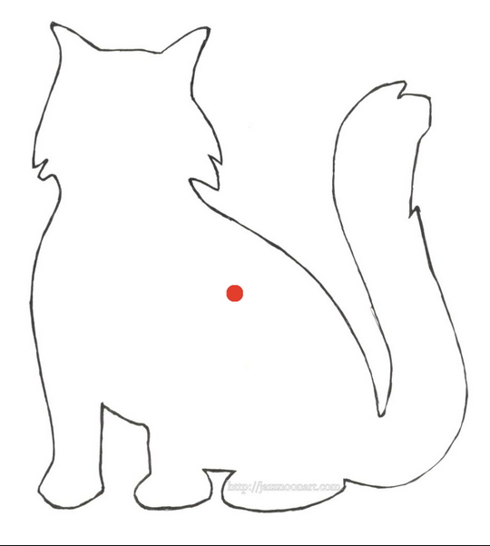
3”
3”

Triangle with seam allowance.
4⅞”
4⅞”

Material:

4 different fabrics.

One light.
One dark.
One medium.
A contrasting colour for the cat.

Cut a triangle from the light and dark fabrics.

Cut pieces 8½” x 3½” from the light and dark fabrics.

Cut an 8½” square from the medium fabric.
Finished size triangle
Actual size
Templates

