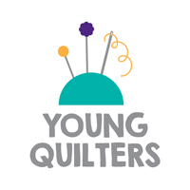
Young Quilters have your say!

Name (optional):
How did you hear about this activity/event?

What did you enjoy about this activity?

Would you change anything about today’s activity?

What other things would you like to do with the YQs?
Young Quilters have your say!
Name (optional):
How did you hear about this activity/event?
What did you enjoy about this activity?
Would you change anything about today’s activity?
What other things would you like to do with the YQs?

