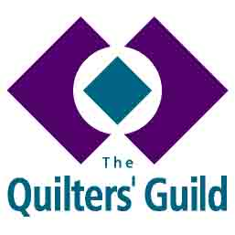
NATIONAL YOUNG QUILTER OFFICER

ROLE DESCRIPTION

The National YQ Officer:

- Is responsible to the Lead Trustee for Education.
- Advises the YQ Project Leader (YQPL) and YQ Reps in regard to quilting and creating projects appropriate to age and ability. These projects are developed further:
  - Helps and advises in regard to FOQ including setting the YQ Challenge and production of ‘In the Spotlight’, when appropriate.
  - Identifies a Christmas project to be created and sent to Young Quilters at the end of November each year
- Supports the production of the Young Quilter magazine in March and September
  - May write articles for the Young Quilter or encourage articles or projects from other contributors.
- Works with YQPL to support the YQ Reps.
- Works with YQ team to ensure that Conference facilities and activities are suitable.
- Sets the Annual AGM Challenge, including the rules for the competition.
- Presents the prizes at the AGM for the Annual YQ Challenge (if they are attending).
- Provides support to YQPL at YQ Reps annual training day.

Respecting Confidentiality
In the course of your duties as a national officer we would ask you to show respect and restraint in not discussing confidential information with others outside the governing body as it is generally not appropriate for members or people from outside The Guild to have access to this type of information. This refers to all types of information, whether or not it is actually flagged as Confidential Information. There will always be situations of ambiguity, please ask if you need clarification and refer back to your Lead Trustee for any matters which are unclear.

