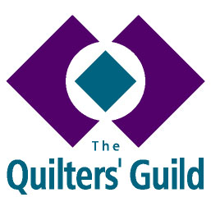
REGIONAL YOUNG QUILTER REPRESENTATIVE
ROLE DESCRIPTION

Responsibilities

- To offer a minimum of two events to Young Quilters (YQ) per year.
- To actively generate interest in the YQs in your region.
- To take part in such training as is arranged by The Guild as relevant to the role.
- To adhere to the relevant guidelines and policies of The Quilters’ Guild, particularly those referring to working with young people.
- To act as an advocate for YQs at regional meetings and events.
- To share your ideas and maintain contact with the National YQ Officer and other representatives through various media.
- To respond to the National YQ Officer and work closely with the Regional Coordinator and others as ambassadors for The Guild.
- To uphold decisions made by the National YQ Officer, Regional Coordinator and Guild Executive.
- To read the Volunteers Handbook/Folder and be aware of the objectives of The Guild in order to be able to answer queries from members and non-members.
- Arrange talks to any other groups or organisations connected with young people about the work of The Guild.
- To attend a minimum of two regional committee meetings a year and be aware that all committee meetings are confidential.
- Maintain an up to date list of YQ members within the region (supplied and maintained by the Membership Officer in Head Office).
- To obtain and maintain a clear, confidential record of parental permission prior to taking photographs which may be used for publicity, magazine articles etc.
- To evaluate all events, activities and projects and provide feedback to the National YQ Officer.

You have also agreed to provide relevant documents to enable The Guild to obtain clearance from The Disclosure and Barring Service (DBS) and to provide the names and contact details of a minimum of two Referees.

Associated Form R09 Working with Young Quilters

