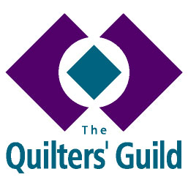
YOUNG QUILTER GROUP LEADER
ROLE DESCRIPTION

Person Specification
A YQ Group Leader must:
- Be a member of The Quilters’ Guild of the British Isles.
- Be willing to complete a DBS check before beginning work with children on behalf of The Guild.
- Submit an application form and provide a minimum of two references.
- Commit to a minimum of 12 months in the role.
- Understand that appointment to the role is the decision of the YQ recruitment team.

Responsibilities
Working with Young Quilters
- To run a local sewing group that meets regularly at an appropriate venue.
- To adhere to the relevant guidelines and policies of The Quilters’ Guild referring to working with young people including the YQ Volunteer Handbook, Child Protection Policy and insurance procedures.
- To ensure YQ activities are risk assessed.
- To encourage young people to join the Young Quilters.
- To obtain and maintain a clear, confidential record of parental permission prior to taking photographs which may be used for publicity, magazine articles etc.
- To recruit adult helpers to assist with local sewing group as you require.
Personal/Professional Development
- To read the YQ Volunteers Handbook and Child Protection Policy and follow best practice in working with children.
- To take part in such training as is arranged by The Guild as relevant to the role.
Administrative Responsibilities
- To share your ideas and maintain contact with the National YQ Officer and Young Quilter Project Leader through appropriate media.
- To report to and provide feedback on activities and projects to the National YQ Officer and Young Quilter Project Leader.
- To uphold decisions made by the National YQ Officer, Regional Coordinator and Guild Trustees.

You have also agreed to provide relevant documents to enable The Guild to obtain clearance from The Disclosure and Barring Service (DBS) and to provide the names and contact details of a minimum of two Referees

