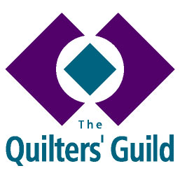
YOUNG QUILTER HELPER
ROLE DESCRIPTION

Person Specification
A YQ Helper must:
- Be willing to complete a DBS check if it is felt to be necessary for your group.
- Complete a Volunteer Registration form and provide a minimum of two referees.
- Agree their commitment level with workshop leader who they are volunteering to help.
- Understand that appointment to the role is the decision of the workshop leader.

Responsibilities

Working with Young Quilters

- Help with workshops organised by a YQ Representative, YQ Group Leader or the YQ Officer.
- To adhere to the relevant guidelines and policies of The Quilters’ Guild referring to working with young people including the YQ Volunteer Handbook and Child Protection Policy.
- To support workshop leaders during sessions but never to take responsibility for and cannot be left in sole charge of YQ members (unless DBS checked by The Guild or has a check accepted by The Guild).
- May not have access to YQ members’ details or be involved in any way with managing communication with YQ members.
- To encourage young people to join the Young Quilters.

Personal/Professional Development
To read the YQ Volunteers Handbook and Child Protection Policy and follow best practice in working with children.

Administrative Responsibilities (optional)
To share your ideas and maintain contact with the National YQ Officer and Young Quilter Project Leader through appropriate media or your Group Leader, if applicable.

