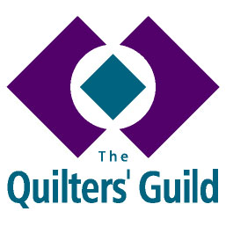
YOUNG QUILTER OUTREACH VOLUNTEER
ROLE DESCRIPTION

Person Specification
A YQ Outreach Volunteer must:
Be a member of The Quilters’ Guild of the British Isles.

Responsibilities

Working with Young Quilters

- Independently seek out a group of young people to work with. Assistance with this can be provided by the YQPL and YQ Officer.
- Work on a one off, short or long term sewing project with the group. Terms of volunteering will be agreed between the YQ Outreach Volunteer and the teacher or leader of the group they are working with.
- A DBS check may be required by the school or group with whom the YQ Outreach volunteer is working. The DBS check should be conducted by the school in most instances, but may be conducted by The Guild at the discretion of the YQ Recruitment team.
- Complete a Volunteer Registration form and provide a minimum of two referees.
- Encourage young people to join Young Quilters.
- To support teachers/leaders during sessions but never to take responsibility for and cannot be left in sole charge of children.
- May not have access to YQ members’ details or be involved in any way with managing communication with YQ members.
Personal/Professional Development
- To read the YQ Volunteer Handbook and Child Protection Policy and follow best practice for working with children.
- Will have support of Guild and YQPL and advice for project ideas.
Administrative Responsibilities
- To share your ideas and maintain contact with the National YQ Officer and Young Quilter Project Leader through appropriate media.
- To report to and provide feedback on activities and projects to the National YQ Officer and Young Quilter Project Leader.
- To uphold decisions made by the National YQ Officer, Regional Coordinator and Guild Trustees.

