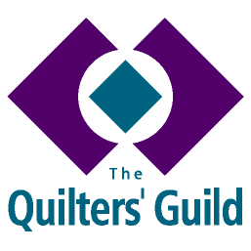
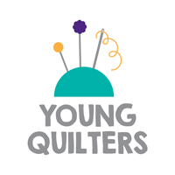
YQ ANNUAL ACTIVITY SUMMARY

To be completed by YQ Reps, Group Leaders, and Outreach Volunteers and returned to The Guild HQ.

This form should be used to record the total of YQ activities which you held or organised in the calendar year (November - October). Please give your best estimate for the number of activities or sessions you held and total number of participants.

Name of person completing this form.................................................................................

Volunteer Role (please circle) YQ Representative YQ Group Leader YQ Outreach
Volunteer

Region..................................... Membership number..................................

About your YQ activities

Please provide information about any of the following which apply to you:

Activity type | Total Number of Sessions/Activities | Total number of participants
YQ workshops
Including workshops at regional days, regular sewing club meetings, school holiday workshops etc.
Outreach sessions
Including workshop with a school, uniform group or after school club, etc.
YQ stall at a festival or show
Exhibition or show of YQ projects

Other (Please give details)

