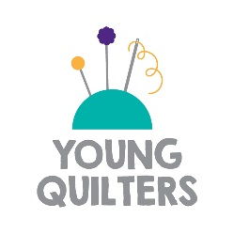

Dear Headteacher’s name,
The Quilters’ Guild is an education charity which has been teaching patchwork and quilting skills since 1979. The Young Quilters Project is The Quilters’ Guild’s initiative to provide children and young people with the opportunity to learn sewing skills from Guild volunteers in schools. As such, it needs the support of schools and individual teachers in coordinating and hosting Young Quilters clubs, but relies on the enthusiasm and skills of Guild volunteers in order to teach sewing skills and techniques.
What’s on Offer to Schools?
Our skilled Guild volunteers are experienced quilters and many are former teachers. Our volunteers receive training in child protection and safeguarding, health and safety and we can provide a DBS check through The Quilters’ Guild if required. Each Young Quilters club can be run in its own way. Some meet monthly or weekly to create a quilt block and then produce a finished quilt. Others meet monthly or weekly to create a useful sewing project such as a cushion or bag within the time of the club meeting.
The advantages of hosting a Young Quilters club includes built in community cohesion, intergenerational working and the chance to take part in national events such as The Festival of Quilts Young Quilters competition. Learning to quilt not only provides a sense of achievement but boosts co-ordination and improves dexterity, maths and handwriting.
What next?
If you would like to host a Young Quilters Club in your school please get in touch as soon as possible. When contacting us to make arrangements for a club, it would be useful to have an idea of the number of children wishing to participate. Please nominate a school contact (the teacher or teaching assistant who will supervise the club) for us to liaise with over times, dates and project planning.
For more information about Young Quilters, please see our website www.youngquilters.org.uk.
We hope you will decide to host a Young Quilters club in your school. Please do not hesitate to contact us if you have any further questions.
Yours sincerely,
Your name
Young Quilters Volunteer

