
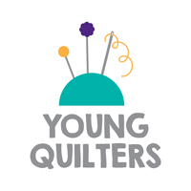
YOUNG QUILTER’S REGISTRATION FORM

For attendance at YQ Workshops

Welcome to Young Quilters! This information is confidential between you and The Guild.
You do not need to complete this form for every workshop,but you must check details have not changed.
Name of attendee:
Preferred name: |  | Gender (male, female, other, prefer not to say)
Date of Birth: |  | Guild Membership Number (if applicable):
Home Address:
Postcode:

Parent/ Legal Guardian details:
Full name:

Email:

Mobile:

Please note: Younger children will never be allowed to leave a YQ Workshop unaccompanied. If you would like someone else to collect your child, please provide their details below:
Name:
Mobile:
Relationship to child:

Medical and special needs information: |  | Yes | No
Does your child have any known medical conditions, known allergies, or special dietary requirements? If yes, please add any information on the back of this form.
Does your child have any special needs or accessibility requirements that you would like us to be aware of? If yes, please add any information on the back of this form.
Who should we contact in an emergency?
Name:
Mobile:

Signed (Parent/Legal Guardian):
Date:

